EMERGENCY CARD 1 Part A: Earthquakes in Japan
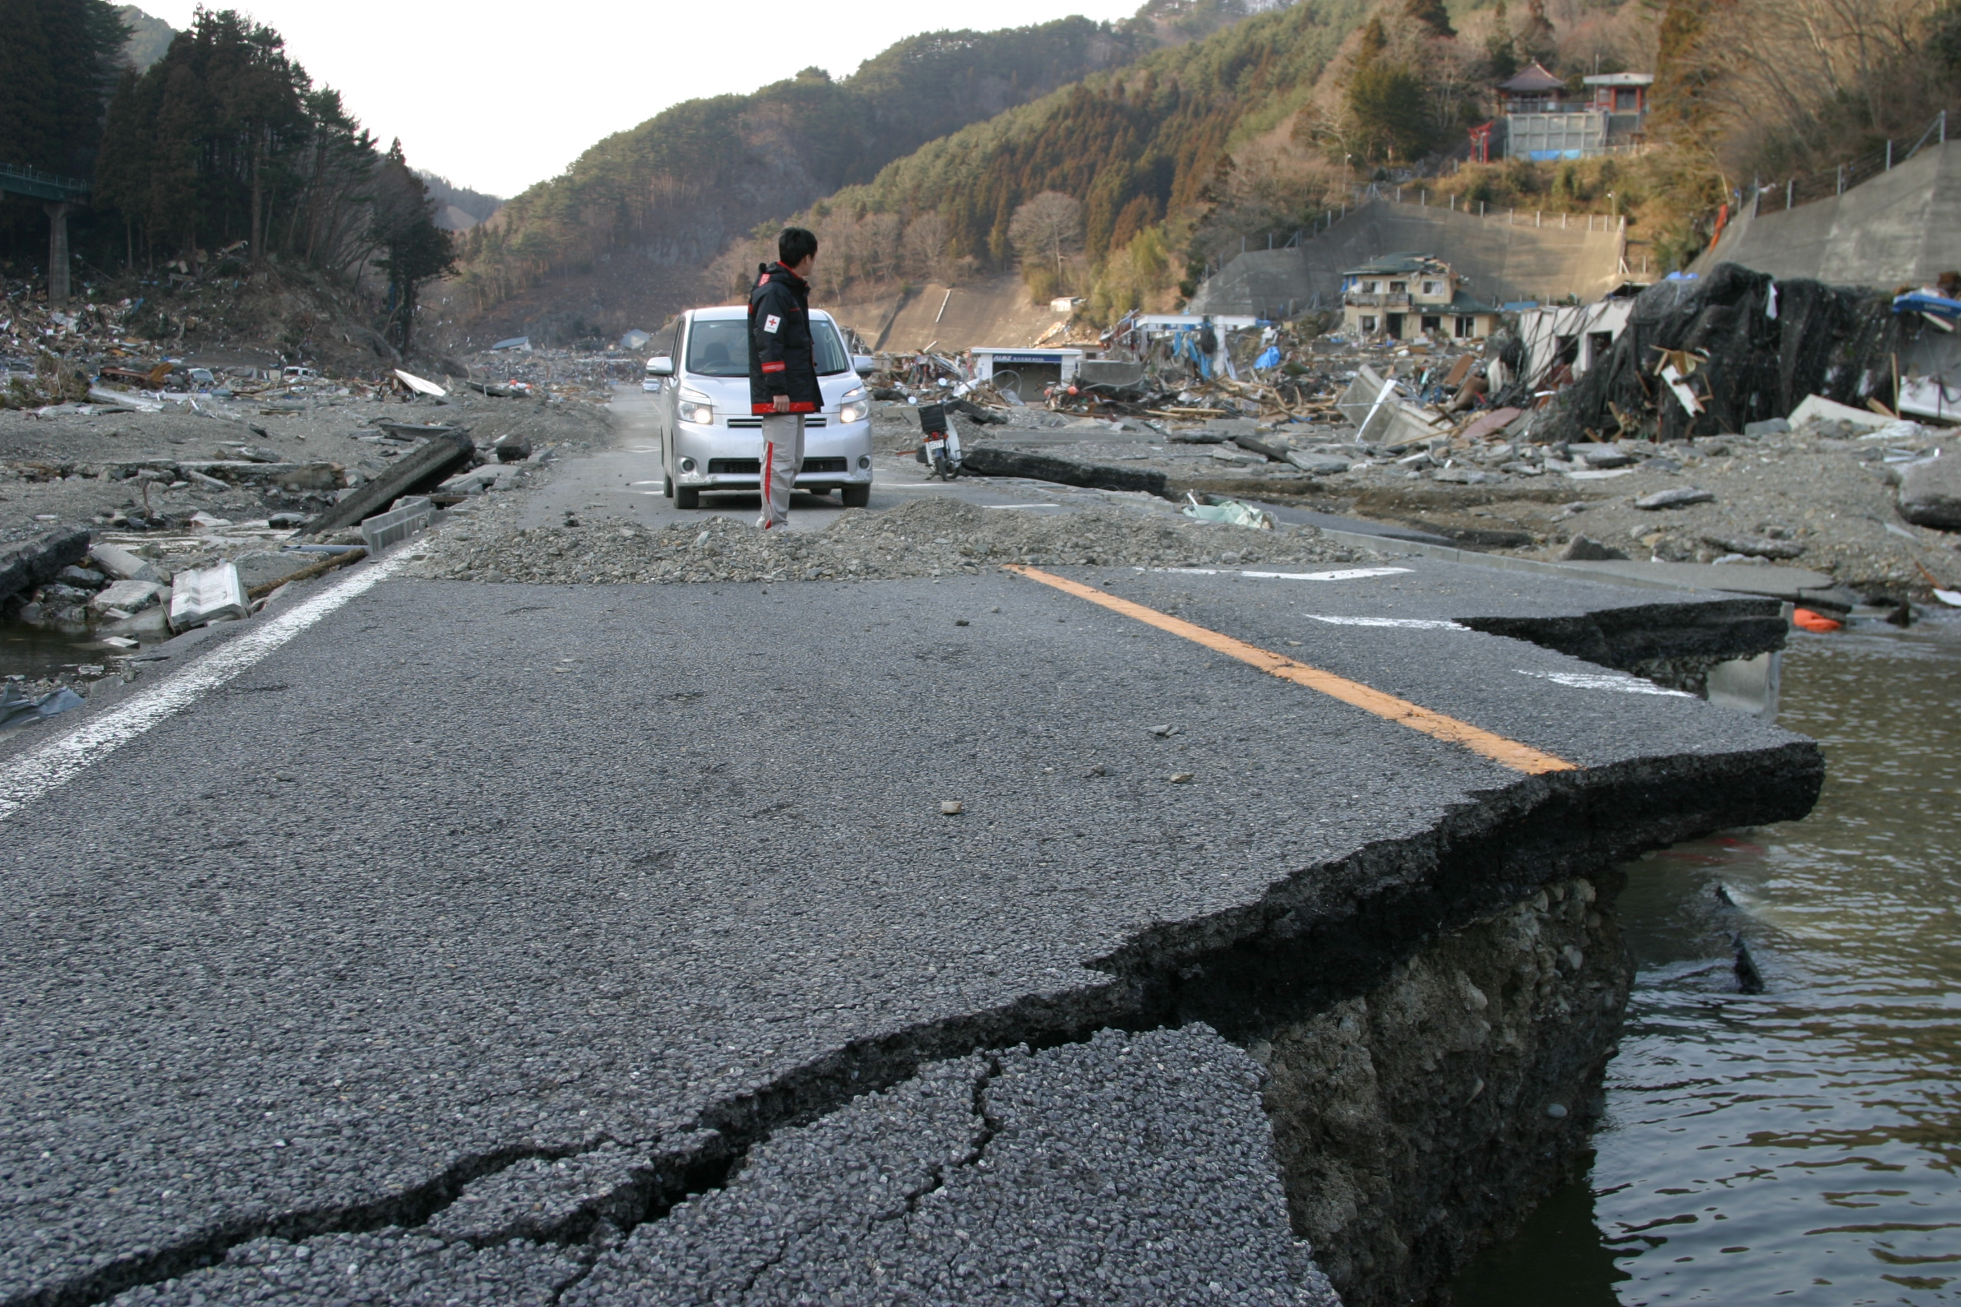 | Earthquakes are when the earth moves and creates vibrations or shaking.  This shaking can be gentle or very strong. Small earthquakes may only cause furniture to wobble, but larger ones can destroy entire towns.  Buildings can fall down, roads and railways can be broken, and there can also be fires and floods.  What could you do to prepare for and respond to an earthquake?

EMERGENCY CARD 1 Part B: Earthquakes in Japan
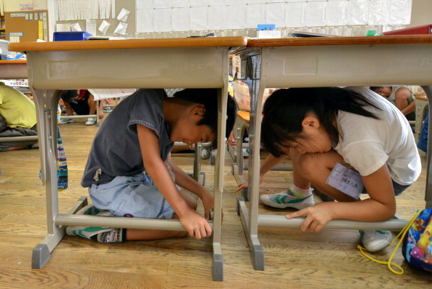 | PREPARE:  Japanese children practice earthquake drills every month at school. Japanese TV and Radio will automatically switch to official earthquake information so that people have information about risks, damage and help.  Most homes, schools and offices have earthquake kits ready with water, some food and first aid supplies.  RESPOND:  Children respond to an earthquake alarm by getting under desks and holding table legs to prevent tables moving. Teachers supervise them whilst putting on helmets, then stand in the doorway of the classroom.

EMERGENCY CARD 2 Part A: Tsunami in Sri Lanka
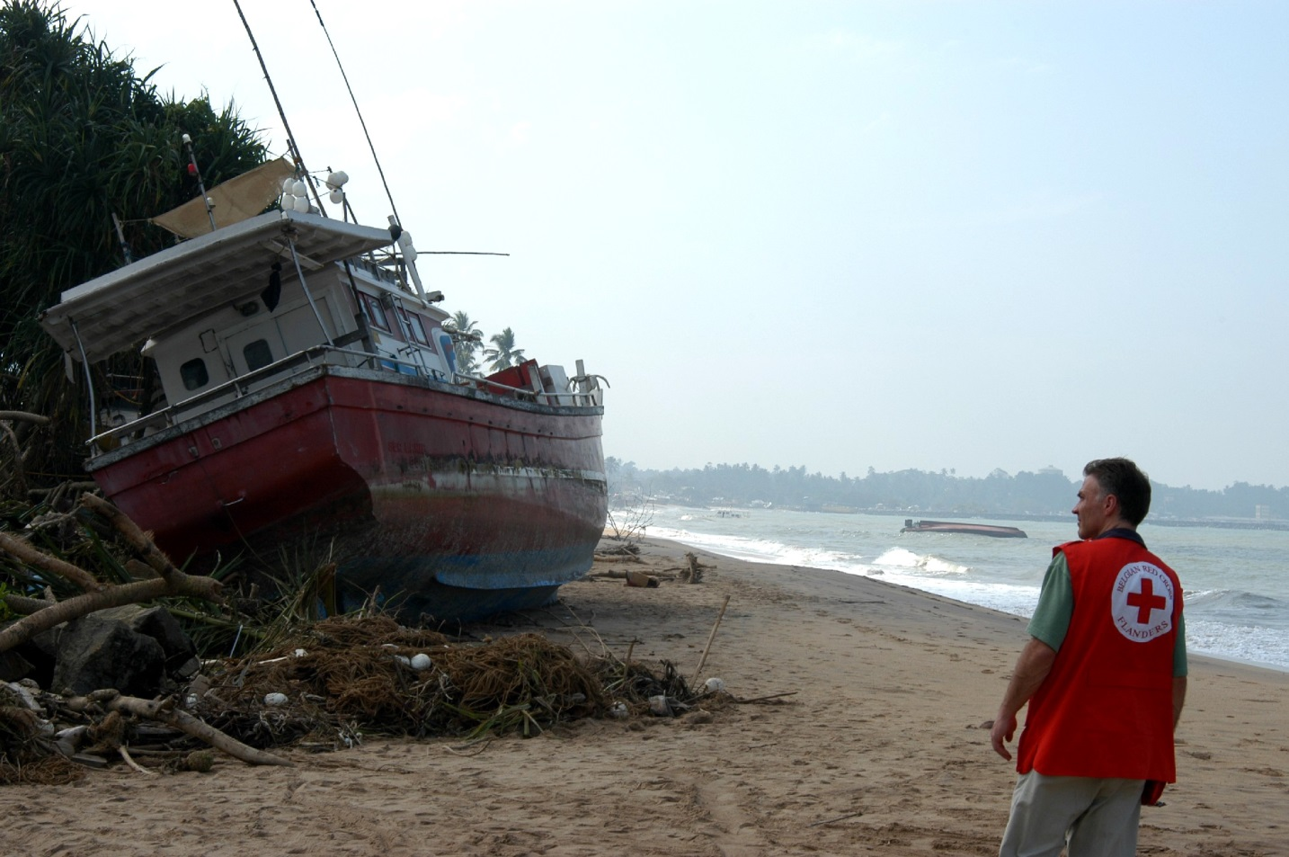 | A tsunami is a huge wave that is normally caused by an undersea earthquake.  This can be dangerous to ships and boats at sea, but is most dangerous when it reaches the land.  It can create waves many metres high that are traveling very fast.  These waves can travel many miles inland, destroying almost everything in their way.  What could people who live near the seashore do to prepare for and respond to a tsunami?

EMERGENCY CARD 2 Part B: Tsunami in Sri Lanka
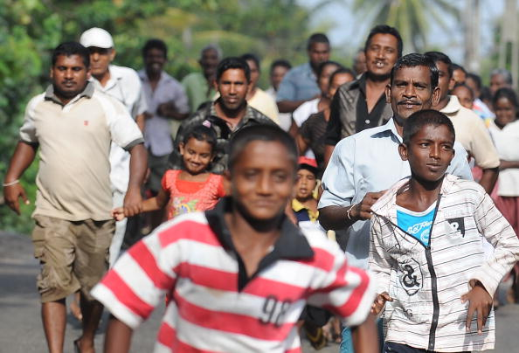 | PREPARE:  In Sri Lanka areas near the seashore held a large tsunami evacuation drill in 2010.  35,000 people were killed by a tsunami that hit Sri Lanka in 2004. Signboards now show people the safe route away from danger. Warning towers on the beaches sound a siren which can be heard 5km (3 miles) away.  RESPOND:  When people hear the siren, they follow the route through the streets running - the type of disaster means that running is the safest thing.  http://www.irinnews.org/report/89840/sri-lanka-tsunami-drill-in-coastal-areas

EMERGENCY CARD 3 Part A: Wildfires in the USA
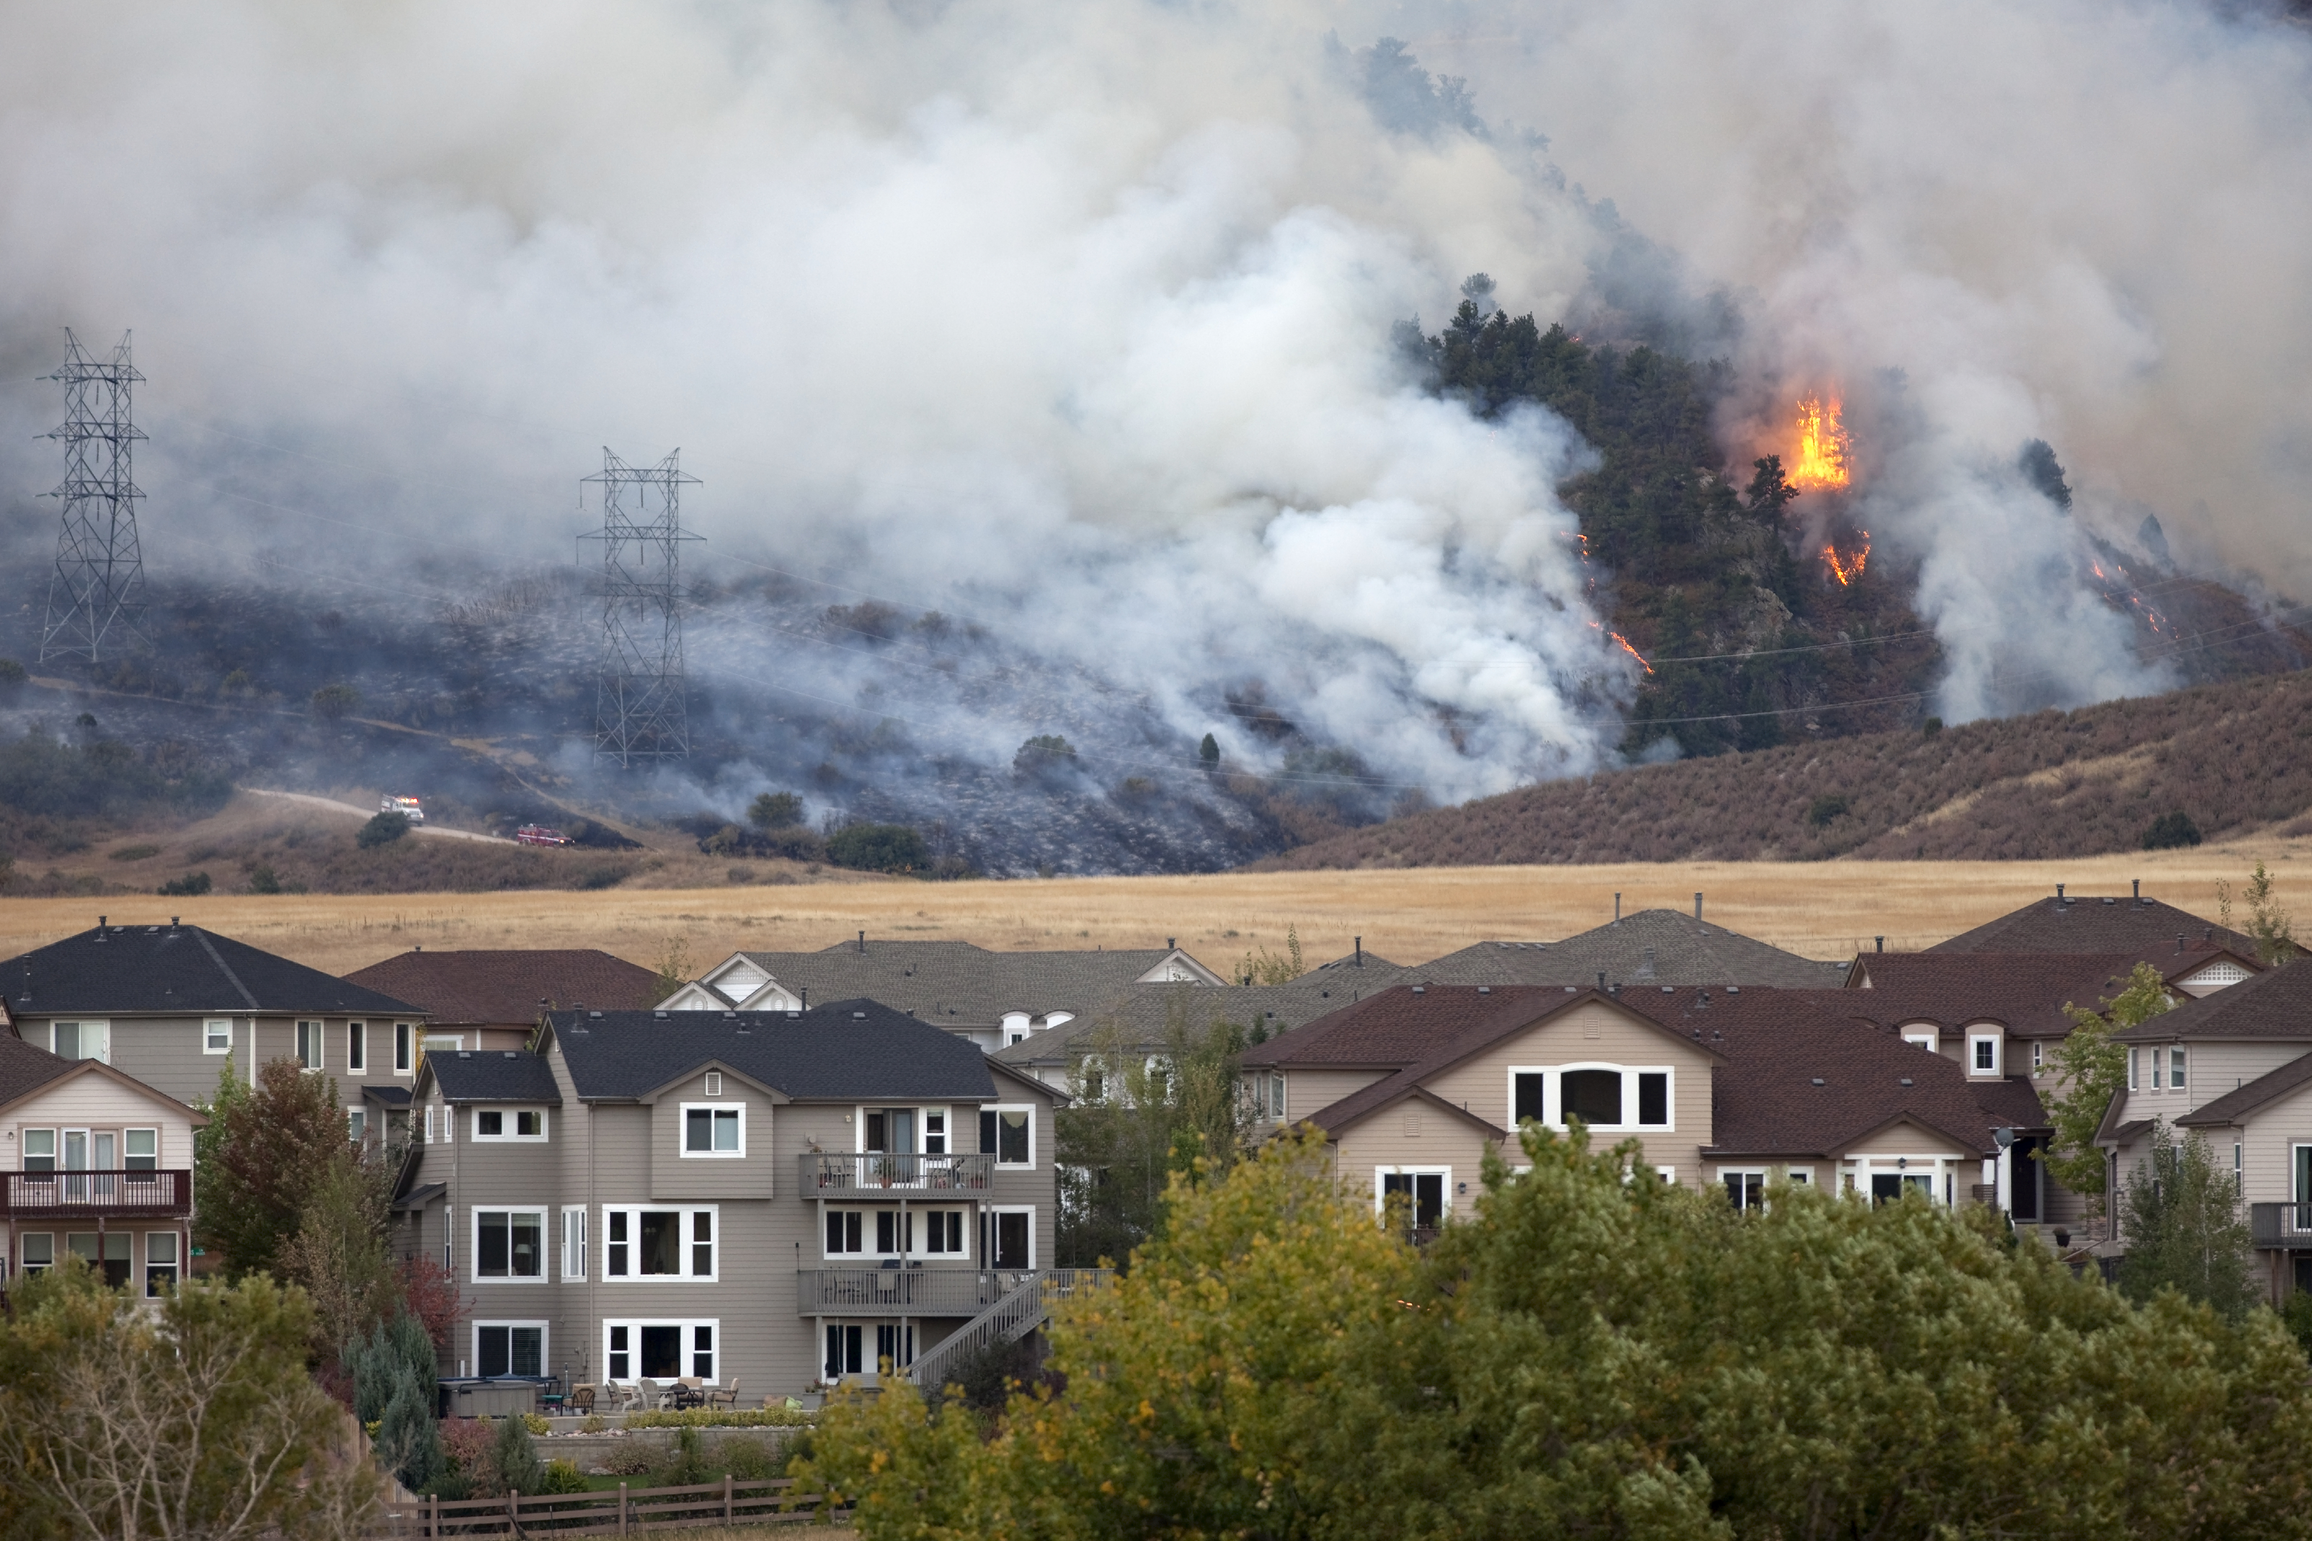 | In the United States of America some areas have regular wildfires or forest fires.  If no one lives there this is a natural part of the forest’s life, and burns away dead areas.  However, if people are living nearby a wildfire can be a disaster and create an emergency.  What could people do to prepare for and respond to a wildfire near their home?

EMERGENCY CARD 3 Part B: Wildfires in the USA
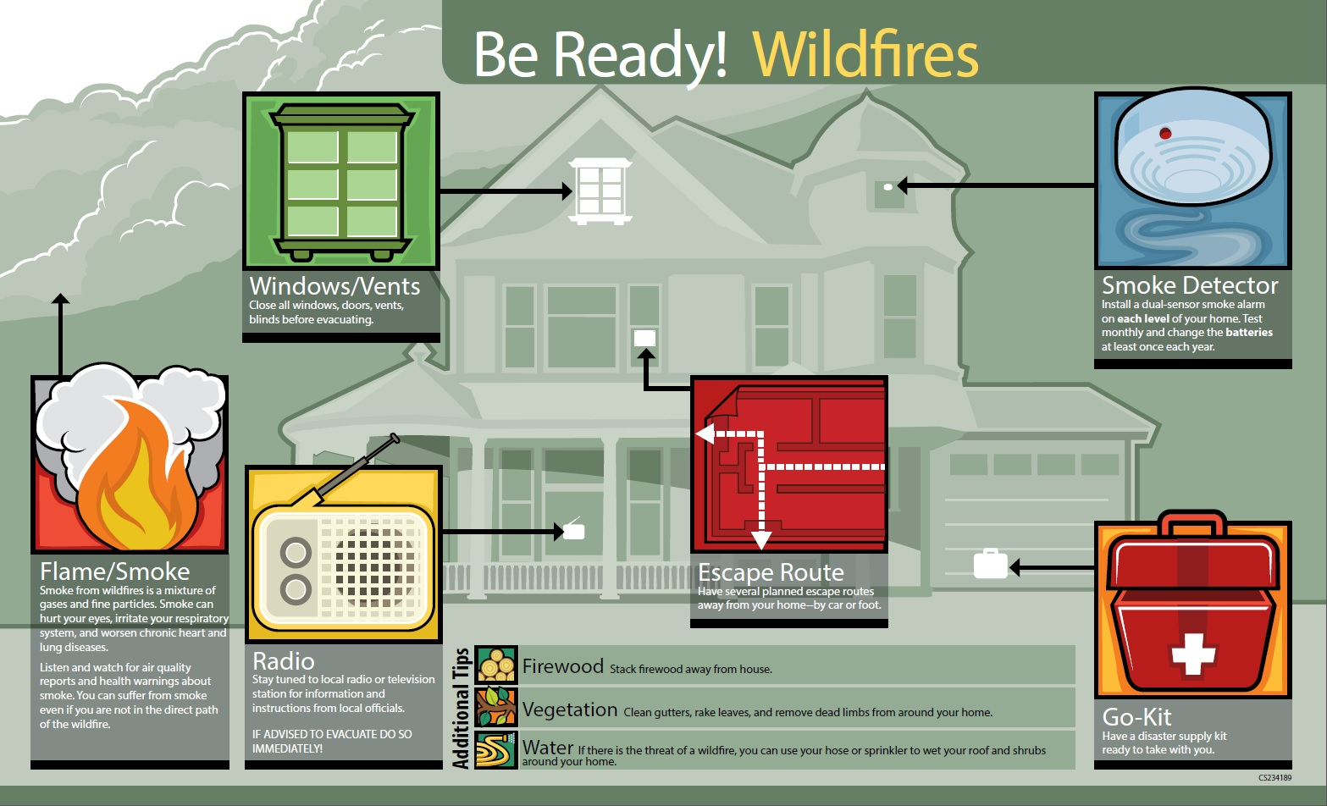 | PREPARE:  People get an evacuation kit ready with water, blankets, medical information (if they need help) and some food.  Check regularly that smoke alarms are working.  Store firewood away from their house.  Emergency services practice wildfire drills with communities at risk.  RESPOND:  Listen for advice on the radio/TV about the weather and fire risk or direction.  Find and follow family disaster plan to get to safety.  Follow any extra/different advice from emergency staff about getting to safety.

Photo credits and captions
Image 1 Japan Red Cross Society: Damaged roads in the affected regions have made access to communities in need all the more challenging. This picture was taken outside Otsuchi in Iwate prefecture. © Japanese Red Cross Society

Image 2 Elementary school children take cover under their desks during an earthquake drill at a school in Tokyo. Photographer: Yoshikazu Tsuno. © AFP / Getty Images

Image 3 After the Tsunami, boats are stranded at the coast of Sri Lanka. December 26, 2004 Tsunami Aftermath, Sri Lanka. © Till Mayer / International Federation of Red Cross and Red Crescent Societies

Image 4 Sri lankan villagers run during a tsunami drill. © LAKRUWAN WANNIARACHCHI AFP/Getty Images

Image 5 Colorado wildfire burns behind homes © iStock / David Parsons

Image 6 http://www.cdc.gov/phpr/documents/BeReady_Widfires.pdf

Important legal note
This photograph is fully protected by copyright. Schools and other educational organisations are free to use it for educational use. The license does not extend beyond this use. This means that anyone wishing to put the image on a website, crop or edit it, or use it in any other way, must first contact the copyright holder and negotiate a license for the use they require.
This resource and other free educational materials are available at redcross.org.uk/education. The British Red Cross Society is a charity registered in England and Wales (220949) and Scotland (SCO37738).

